**Implicit Parameter**

In scala.math there are some function already defined for ordering. These functions can be passed as function parameter.

For instance : **def** mergeSort[T](listToBeSorted: List[T]) ( ordering: Ordering[T]) : List [T] = {

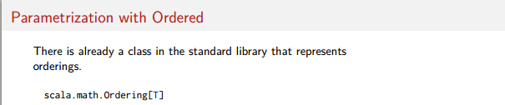

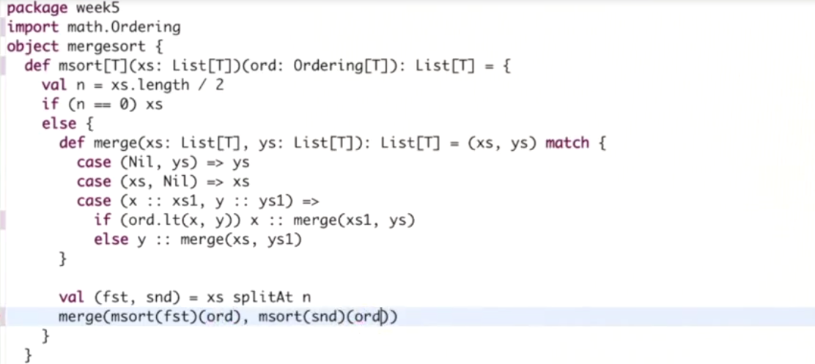

In a method call

**val** numList = 1::9::5::6::*Nil*  
*val* result= mergeSort(numList)(Ordering.Int)  
  
val stringList = **"S"**::**"A"**::**"C"**::*Nil*  
*val* result1= mergeSort(stringList)( Ordering.String)

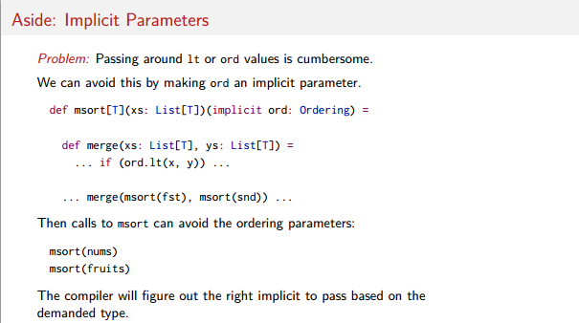

Using implicit the compiler will work out the data type in each method call.

**val** numList = 1::9::5::6::*Nil*  
*val* result= mergeSort(numList)  
val stringList = **"S"**::**"A"**::**"C"**::*Nil*  
*val* result1= mergeSort(stringList)